ATM

Management System

*Project Software Engineering*

*Names:*

*Omar seraj altalhi – 43904989*

*Jehad wasllalh alqurashi – 43900605*

*Khalid matar alharthi – 43902078*

*Ali Abdullah alshehri – 43900886*

Table Of Contents:

|  |  |
| --- | --- |
| page | subject |
| 3 | Abstract Project |
| 4 | System Overview |
| 6 | Methodology |
| 7 | Time Plan - Grant chart |
| 8 | Requirement Specification |
| 11 | E-R Diagram |
| 13 | DFD’s |
| 15 | UML Diagrams |
| 16 | Use Case |
| 17 | Class |
| 18 | Activity |
| 19 | Sequence |
| 20 | Collaboration Diagrams |
| 21 | State chart Diagrams |
| 22 | Component Diagrams |
| 23 | Which Architectural pattern use in project? |

Abstract Project

An ATM, which stands for automated teller machine, is a specialized computer that makes it convenient to manage a bank account holder's funds. It allows a person to check account balances, withdraw or deposit money, print a statement of account activities or transactions, and even purchase stamps

System Overview

An automated teller machine (ATM) is a specialized computer that allows bank account holders to check their account balances, withdraw or deposit money, transfer money from one account to another, print a statement of account transactions, and even purchase stamps.

The first ATM was set up in June 1967 on a street in Enfield, London at a branch of Barclays Bank, credited to a British inventor named John Shepherd-Barron.

The social backdrop in different countries in the 1960s and 1970s played a pivotal role in furthering the cause of ATMs. Their advent revolutionized the field of banking and changed the way banks interacted with their customers.

Methodology (Process Model)

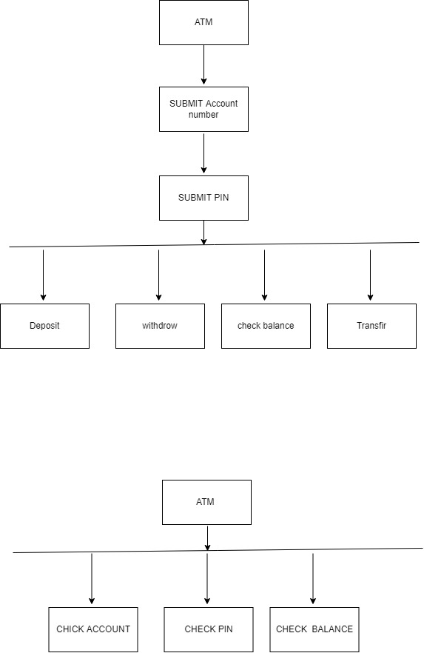

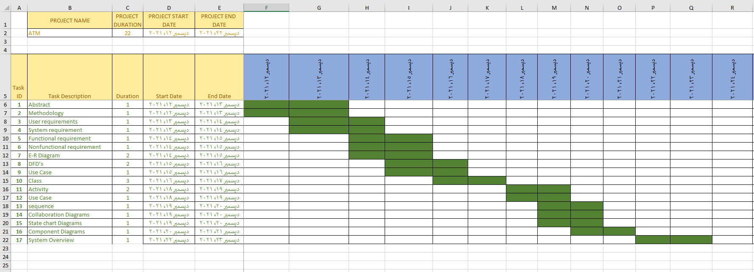Time Plan - Grant chart

Requirement Specification

User requirements:

can be broken down into two categories:Functional and Non-Functional

Functional and Non-Functional requirements,or Functional specifications,are not term specific to ATM machines.User requirements refer to user needs.For Example,What the user actually does with the system and what activities the user should be able to perform.The customers and their needs inform manufacturer decisions about upgrades and model adjustments.

Functional Requirements are mandatory These are the requirements that users expect each time they visit an ATM machine.

Functional requirements consists :

- Correct PIN allows Transactions

- Dispenses cash

- Receipt printed upon demand

- Default to idle upon completion of transactions

Non-Functional :

- Must be entered correctly within a certain number of attempts

- Can be opened and refilled with cash

- Can be opened and refilled with paper

- Can be shut down and restarted

System Requirements :

Hardware Requirements:

Processor : Intel Pentium 4 or later or Compatible

Hard Disk : 410GB or more

RAM : 1GB or more

Printer : Any

Monitor : SVGA Color Monitor(Touch Screen)

Pointing Device : Touch Pad or Keys

Software Requirements :

Operating System : Microsoft Windows XP or Later or Equivalent

Front End:Visual Basic 6.0

Back End : Oracle 8i

E-R Diagram

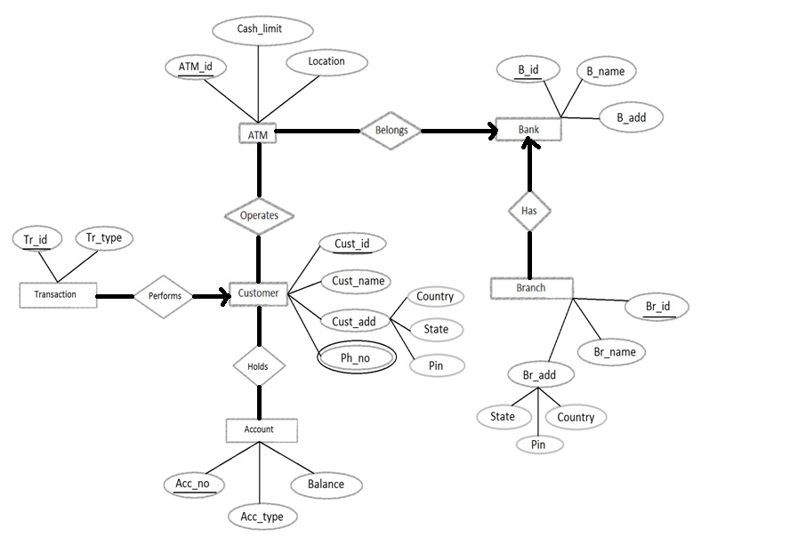

DFD’s

DFD’s

Level 0 DFD :

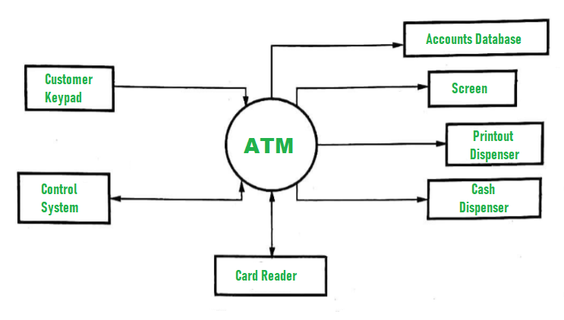

Level 1 DFD:

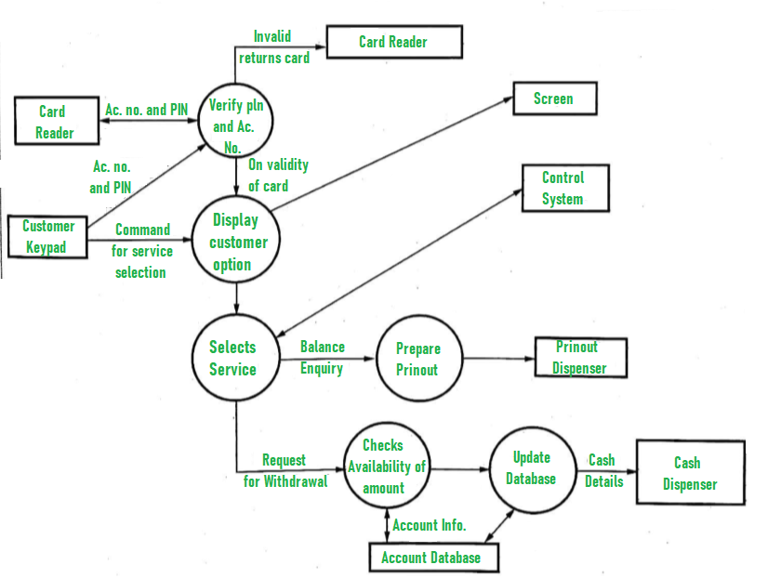

UML Diagrams

Use Case

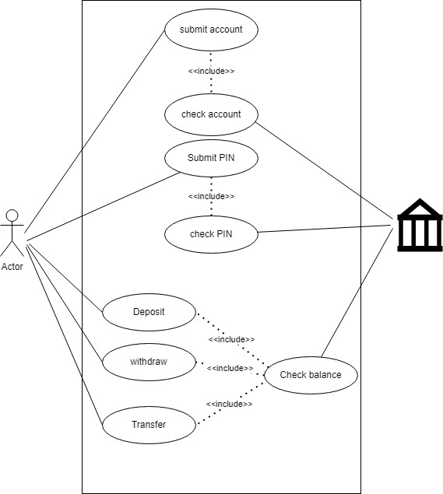

Class Diagrams

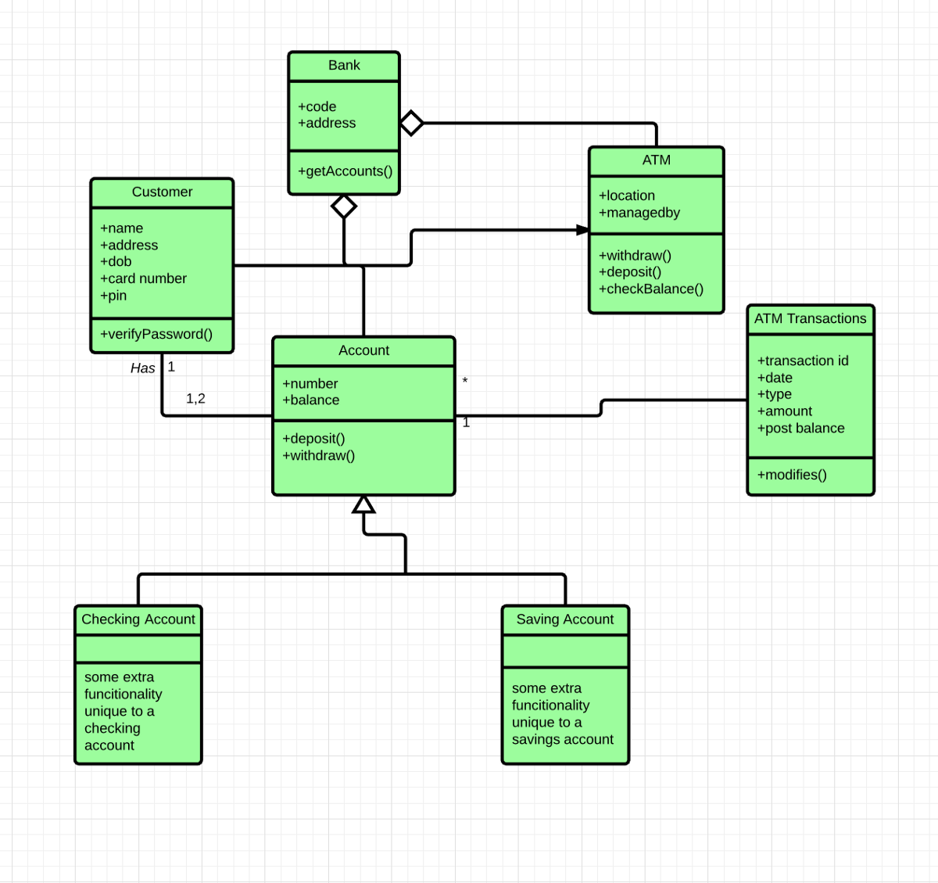

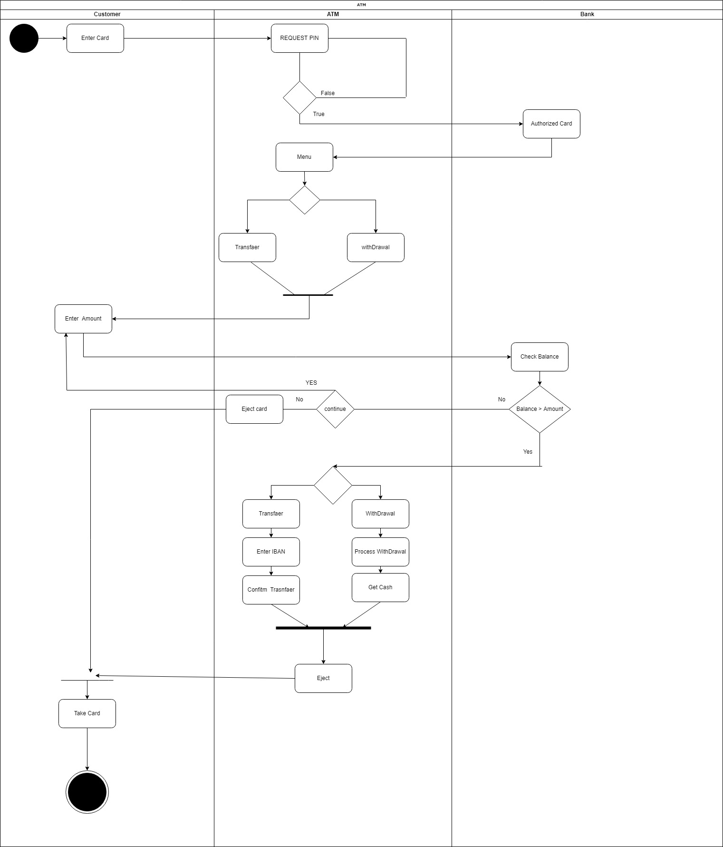Activity Diagrams

Sequence Diagrams

صورة تحتوي على منضدة

تم إنشاء الوصف تلقائياً

Collaboration Diagrams

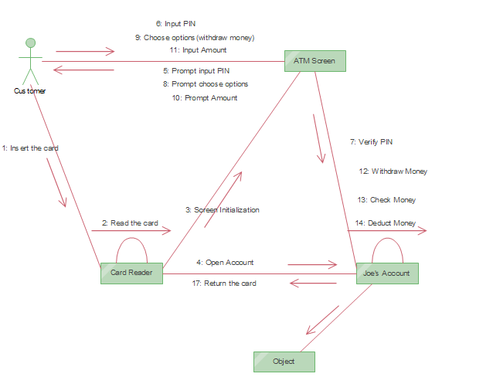

State chart Diagrams

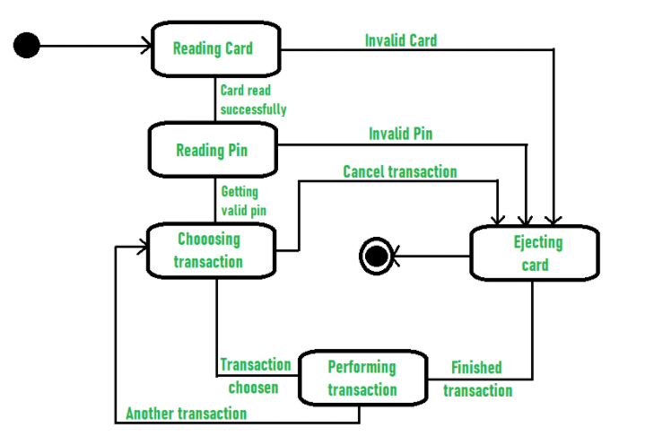

Component Diagrams

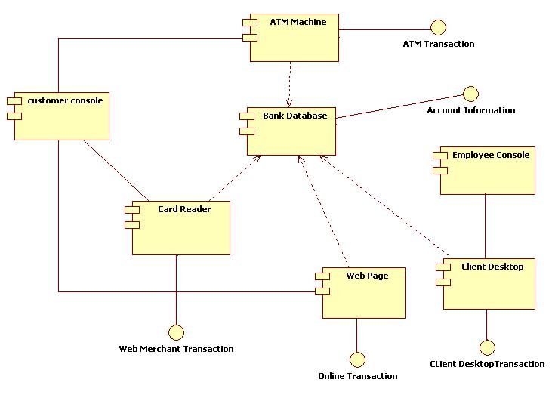

**Architectural pattern of ATM**

|  |  |
| --- | --- |
| Name | ATM( **Automated Teller Machine** ) |
| Description | An automated teller machine (ATM) or cash machine - is an electronic telecommunications device that enables customers of financial institutions to perform financial transactions, such as cash withdrawals, deposits, funds transfers, balance inquiries or account information inquiries, at any time and without the need for direct interaction with bank staff. |
| Example | An account holder can use an ATM to carry out a number of transactions.  Withdrawals are the most common transaction among ATM cardholders. This allows them to withdraw cash from their accounts. For a withdrawal, account holders just have to key in the amount they wish to take out.  ATM deposit also are becoming popular. Account holders can deposit money and checks if their bank allows it.  Balance inquiries allow account holders to view their current account balance. This feature may be helpful if account holders need to know the amount of money they can spend with their debit card or credit card.  Transfers and payments are also available depending on the bank. This allows account holders to move money from one account to another, without withdrawing cash. |
| When Used | We use an automated teller machine when you need to deposit, exchange or transfer money |
| Advantages | -Quick and prompt service is possible with less human errors.  -It is beneficial for travelers.  -It provides 24 hrs services without any staff and reduces the work load on bank staff.  -Withdraw cash at any time or in urgent without the help of bank.  -It ensures privacy to the customers.  -The withdrawal of rupees is faster than bank, no need of standing long lines.  -Maintenance cost is less as no bank staff is involved in transaction.  -It also provides receipt for details of withdrawal of money and balance in account. |
| Disadvantages | -It cannot provide services in rural region in our country whereas banks are available in the villages.  -Customers do not have proper knowledge of its operation so feel hesitate to use it.  -If ATM card is lost, no withdrawal of rupees. There is possibility of misusing and hack the ATM card.  -If dispense error in ATM machine, not received rupees but account will be debited.  -Personal touch of customers-employee relation is missing.  -Due to leakage of PIN, fraud can take place easily.  -Initial cost of hardware, software, and installation site is very high.  -Limitation of withdrawal of money. |